Step 1 | Register and Complete verification
Please register to verify your qualifications by entering your details at:

swansea.qualificationcheck.com

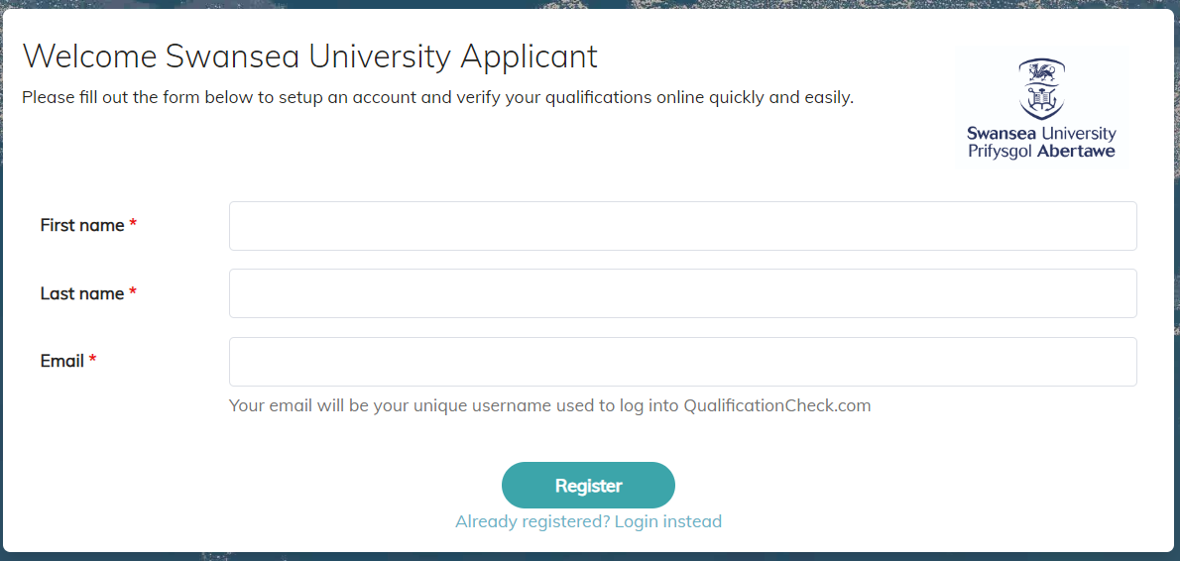

Check your inbox for an e-mail from: do-not-reply@qualificationcheck.com with the subject line: ‘Verify your QualificationCheck.com Registration’.

Follow the link that says “Verify Email”, enter the required details and create your password to complete login.

Step 2 | Applicant Details & Institute Search
Once logged in, select whether you are applying for undergraduate (UG) or postgraduate (PG) studies in the Level of Study field, and complete the remaining application questions.

Once the questions are completed, you will be instructed to type the name of the institution that awarded your qualification. (e.g. the University/institute that issued your last qualification). We recommend filtering by country first for the most accurate results.

As you type a list of institutions will appear at the bottom. Click on the name of the institution where you studied.

Step 3 | Enter Qualification Details
You must enter your individual details (name and date of birth) as they appear on your qualification. You must then enter the required qualification details as instructed on the portal and providing as much information as you can.

You can also add comments and/or additional information if necessary.

Step 4 | Consent and Other Documents
Scroll down to the Documents Section. Below the Institute Consent Form click where it says ‘Download & Sign’. This will open a consent form document.
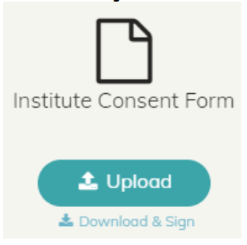

Please complete and sign the form then upload it by clicking on the ‘Upload’ button. E-signature accepted by institutions unless otherwise stated.

If the institution requires additional documentation for the verification (e.g. degree certificate), please upload a PDF version to the portal to be submitted along with the rest of your details.

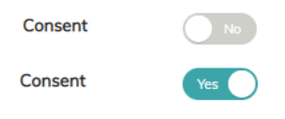
Remember to click the consent button so that it changes from No to Yes:

Once you have done this, you can click the next button to submit your details for verification.
Step 5 | Submit and Complete application & Payment
 | At this point a screen will pop-up asking you to confirm whether you have submitted all relevant qualifications to be verified. If you have, click on the ‘Yes, Submit & complete application’ button.
Step 6 | Payment
 | You will need to pay a standing cost of £30 plus any surcharge from your previous institution. Enter your Payment Details and then click on the ‘Pay’ button.
Step 7 | Wait
 | Qualification Check will verify your qualification directly with the awarding institution. Please be patient as this can take time as they check their records.
Step 8 | Verification Confirmation
Once your qualification has been verified you will receive an email to notify you.

Your verification result will be automatically shared with Swansea University.
Please note:
If you get stuck, click on this button at the bottom right of the page and type your query in the chat:
Alternatively, you can reach out to the Qualification Check team directly through the following email address: applicantsupport@qualificationcheck.com

